Tips for Semester Exam Project
Save a picture
Select image, right click on it, select “Save image as,” select Pictures folder, name it if needed, and save.

Add image
Click the plus sign, select image, click on the “Add an image” box, click on suggested (on the right side of screen), select “My device” from the drop-down options, find the picture folder, select picture you want, and double click.

Add a fact
One fact per slide! Click the plus sign, select text, and type your fact in the text box.

Grouping
Group each fact to one picture so they will show up together by grouping. Do this by, selecting the slide you want to group. Click the box in the bottom right corner of the slide. Click the box in the bottom right corner of the other slide you want to group it with and then click “Group.”

Adjusting picture
If your picture appears too big and zoomed in, while editing, click on the picture and then click on Focus Points. Click the box that says, “The entire image is important.”

Design
Change the font, color, and settings under the design tab. Remix will give you a random setting.

When finished:
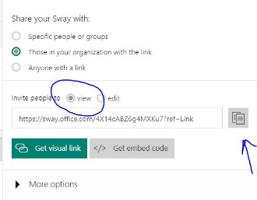
Click share in the top right corner. Under “Invite people to” select “view.” Copy the link by clicking the box the arrow is pointing to.

Now go to outlook. Click the “New” button to create a new email. Send to kwaldon@ssisd.net with subject saying Landmark Project. In the message box, right click and select paste. Lastly, click send.

